|  |
| --- |
| Difference Between NAAC & NBA Accreditation - Haq Se EngineerPREC LONIJai Shriram Engineering College (@JSREC09) / Twitter**JAI SHRIRAM ENGINEERING COLLEGE**  **TIRUPPUR – 638 660**  Approved by AICTE, New Delhi & Affiliated to Anna University, Chennai  Recognized by UGC & Accredited by NAACandNBA (CSE and ECE) |

**DEPARTMENT OF**

**ELECTRONICS AND COMMUNICATION ENGINEERING**

**IBM - Naan Mudhalvan**

**Internet of Things**

**Group 3**

**Phase 5 – Project Documentation and submission**

**TITLE: AIR QUALITY MONITORING SYSTEM**

**NAME : KAVINESH KUMAR S**

**NM ID : AU711221106302**

**YEAR : III**

**Introduction:**

At present, the humans are unaware of the environmental protection and harmness that caused due to the development in the technology. Mainly, the emission that are caused by the over usage of the vehicles and the gases released from the industrial sector which heavily affects the entire atmosphere including the human’s health. Hence, the main focus of this project is to provide the awareness and affection level of the harmful gases which is very dangerous to human life.

**Project definition:**

The primary purpose of an air quality monitoring based on the equipment and systems created is to monitor the air pollution and to distinguish between areas where pollutant levels violate an ambient air quality standard and areas where they do not.As health-based ambient air quality standards are set at level of pollutant concentrations that result in adverse impacts on human health, evidence of levels exceeding an ambient air quality standard in an area requires a public air quality agency to mitigate the corresponding pollutant. This safety equipment has become a compulsory in every building especially in industrial area in order to be a aware of the air quality level and avoid the hazardous area.

**Project design:**

The development of this system via Blynk platform allows the air quality level in parts per million data to be stored in an online database, thus allowing the public to continuously monitor the air quality level and avoid themselves to be exposed rapidly to these harmful gases. The developed hardware system consists of the MQ135 gas sensor. The gas sensor is able to sense the present of gases through the chemical reaction when the gases flows close to the sensor. The reading of air quality level appears on LCD. There are two mains part of the design which are hardware design and software design.

**Existing System:**

The Present Mobile air quality monitoring only provides the data on gas level, temperature and humidity of the surroundings which makes the people to be unaware of harmful gases that endangers their life. This System is used for monitoring and controlling that are extracted from the sensors.

**Development Idea:**

Our aim is to develop a improved version of the current existing system by indicating danger levels of the harmful gases in the surroundings around the user and the user can findout the level by using the Blynk IoT where the danger levels are monitored from the extracted data that are collected from the sensor.

**Block Diagram:**

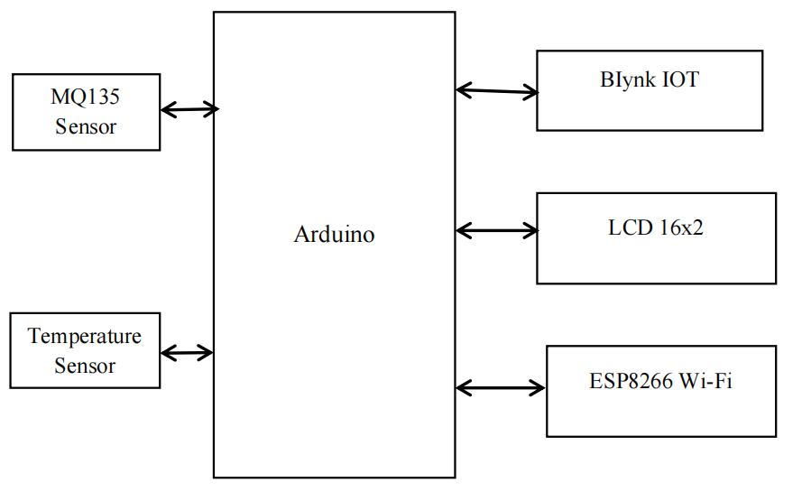

**Arduino UNO:**

* The Arduino UNO board is mostly used by the beginners that can use in electronics project and do programming in this board.
* Arduino UNO is a microcontroller board based on the ATmega328P. It has 14 digital input/output pins, 6 analog inputs, a 16 MHz ceramic resonator, a USB connection, a power jack, an ICSP header and a reset button.
* Arduino consists of both a physical programmable circuit board IDE that runs on your computer which is used to write and upload computer code to the physical board.

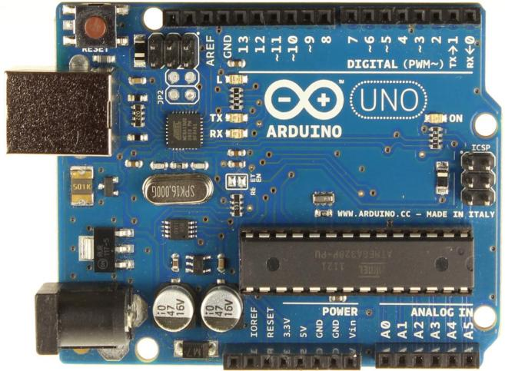

* It uses a variant of the C++ programming language. The code is written in C++ with an addition of special methods and functions.

**Temperature Sensor:**

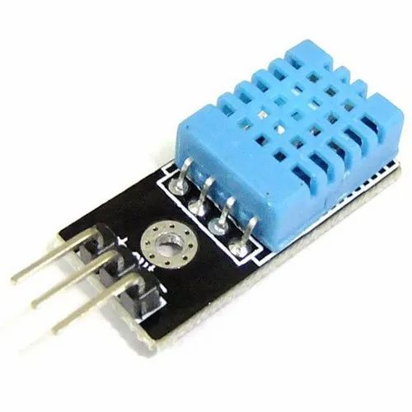

* + A temperature sensor is a device which is a thermocouple or RTD, that is used for temperature measurement through an electrical signal.
  + A thermocouple is made from two dissimilar metals that generate electrical voltage in direct proportion to changes in temperature.
  + An RTD that stands for Resistance Temperature Detector is a variable resistor that will change its electrical resistance in direct proportion to changes in temperature in a precise, repeatable and nearly linear manner.

**Humidity Sensor(Hygrometer):**

* Humidity sensors are electronic devices enabling you to measure the environment’s humidity and convert the data into a corresponding electrical signal.
* It detects changes in temperature or electrical currents in the air by using a humidity probe connected to a receiving device.

**Gas Sensor - MQ135:**

* + Gas sensor is a device which detects the presence of gases in the atmosphere.
  + The Gas that the sensor could detect depends on the sensing material present inside the sensor.

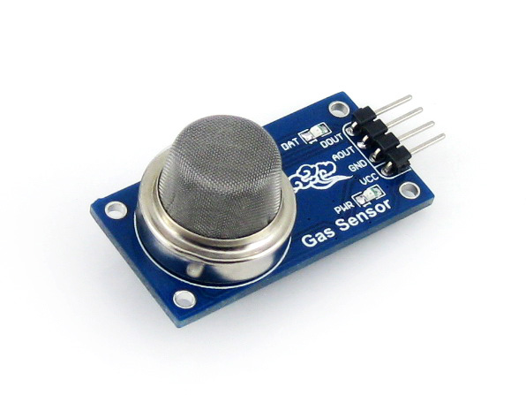

* + The comparators used in the sensor can be set for a particular threshold value of gas concentration. When the concentration of the gas exceeds this threshold the digital pin goes high. The analog pin can be used to measure the concentration of the gas.

**Wi-fi Module(ESP8266):**

* + ESP8266 is a wi-fi module microchip which has a inbuilt TCP/IP networking software.
  + This is used as a station for connecting the device to the wi-fi network.
  + It can also connect other station to the ESP modules by operating as a access point.

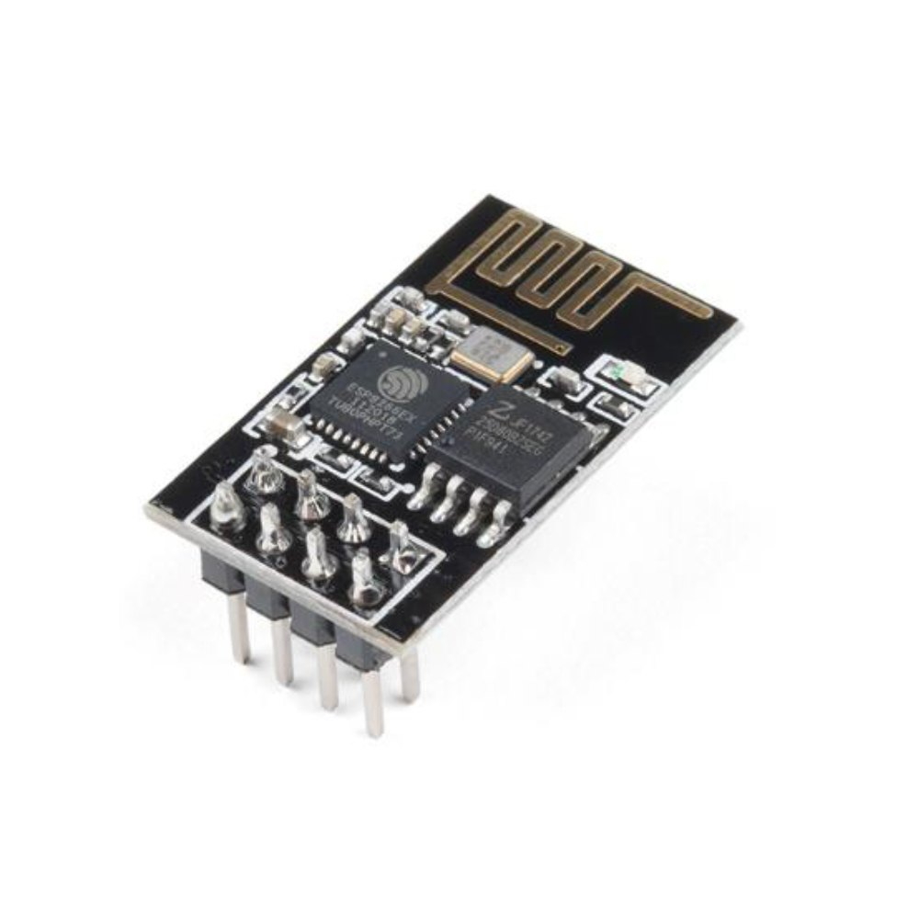

**Blynk IoT:**

* Blynk is an IoT platform which is used to build projects for controlling and monitoring the extracted data by using devices such as android and iOS more quickly.
* By using blynk platform, we can create dashboards for the projects and for promoting various tools.
* It can be performed in Arduino, by using the code “**Blynkrun()**” which is stored in the library and for serial connection between the board and internet, we need to run the **blynk.ser** file that present in the scripts section of the blynk folder.
* The Blynk can run over 400 hardware modules where the popular ones are ESP32, ESP8266, Arduino, Raspberry pi,etc.,
* We can send the processed data from any sensors that is connected to the MCU board where the data flows through a data stream using Blynk protocol when the data is sent to Blynk platform.

**Implementation of Project:**

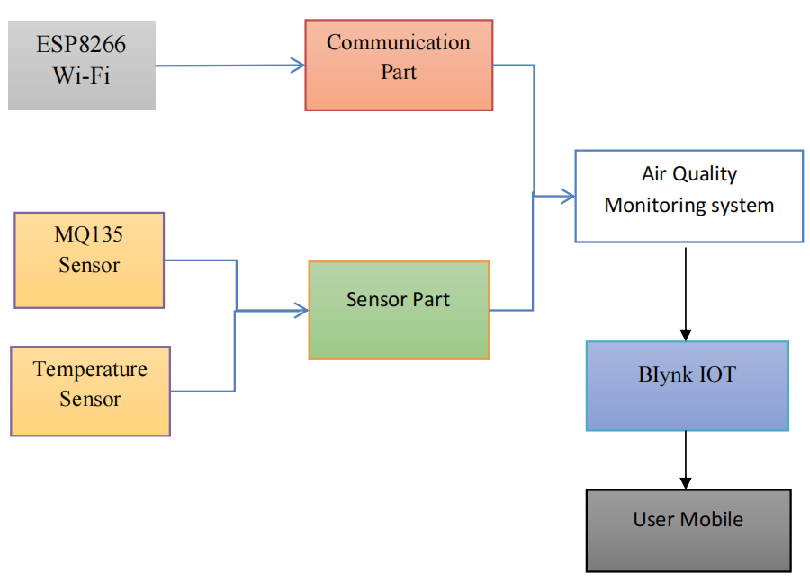

The Processing of air quality monitoring system has two parts: one is communication part and the other is sensor part. The Communication part is used for wireless communication between the devices and it consists of a wireless module ESP8266. The sensor part consists of MQ135 sensor and temperature sensor where gases and the temperature are measured and monitored. Then by comparing extracted data from the both communication and sensor part used for air quality monitoring system and by using the Blynk IoT application. We can identify the danger levels of gases around the user for measuring the data from the sensors. The users can access these data by the Blynk platform in their mobile.

**Program:**

BLYNK_TEMPLATE_ID=&quot;TMPLgwKssgggsnFXp&qut;

BLYNK_DEVICE_NAME=&quot;AirQualityMonitoring&quot;

BLYNK_AUTH_TOKEN=&quot;k03gT6nJosdsfsffesrJV_S5SXEAdgdsdghhgPZvXEwSKDfj&quot;

BLYNK_PRINT = Serial

import ESP8266WiFi

import BlynkSimpleEsp8266

import DHT

import LiquidCrystal_I2C

lcd = LiquidCrystal_I2C(0x27, 16, 2)

degree_symbol = [

0b00111,

0b00101,

0b00111,

0b00000,

0b00000,

0b00000,

0b00000,

0b00000

]

auth = BLYNK_AUTH_TOKEN

ssid = &quot;&quot; # type your wifi name

pass = &quot;&quot; # type your wifi password

timer = BlynkTimer()

gas = A0

sensorThreshold = 100

DHTPIN = 2 # Connect Out pin to D2 in NODE MCU

DHTTYPE = DHT11

dht = DHT(DHTPIN, DHTTYPE)

def sendSensor():

h = dht.readHumidity()

t = dht.readTemperature() # or dht.readTemperature(true) for Fahrenheit

if (isnan(h) or isnan(t)):

Serial.println(&quot;Failed to read from DHT sensor!&quot;)

return

analogSensor = analogRead(gas)

Blynk.virtualWrite(V2, analogSensor)

Serial.print(&quot;Gas Value: &quot;)

Serial.println(analogSensor)

# You can send any value at any time.

# Please don&#39;t send more that 10 values per second.

Blynk.virtualWrite(V0, t)

Blynk.virtualWrite(V1, h)

print(&quot;Temperature : &quot;, t)

print(&quot; Humidity : &quot;, h)

def setup():

Serial.begin(115200)

Blynk.begin(auth, ssid, pass)

dht.begin()

timer.setInterval(30000, sendSensor)

lcd.begin()

lcd.setCursor(3,0)

lcd.print(&quot;Air Quality&quot;)

lcd.setCursor(3,1)

lcd.print(&quot;Monitoring&quot;)

delay(2000)

lcd.clear()

def loop():

Blynk.run()

timer.run()

h = dht.readHumidity()

t = dht.readTemperature()

gasValue = analogRead(gas)

lcd.setCursor(0,0)

lcd.print(&quot;Temperature &quot;)

lcd.setCursor(0,1)

lcd.print(t)

lcd.setCursor(6,1)

lcd.write(1)

lcd.createChar(1, degree_symbol)

lcd.setCursor(7,1)

lcd.print(&quot;C&quot;)

delay(4000)

lcd.clear()

lcd.setCursor(0, 0)

lcd.print(&quot;Humidity &quot;)

lcd.print(h)

lcd.print(&quot;%&quot;)

delay(4000)

lcd.clear()

if gasValue &lt; 600:

lcd.setCursor(0,0)

lcd.print(&quot;Gas Value: &quot;)

lcd.print(gasValue)

lcd.setCursor(0, 1)

lcd.print(&quot;Fresh Air&quot;)

print(&quot;Fresh Air&quot;)

delay(4000)

lcd.clear()

elif gasValue &gt; 600:

cpp

lcd.setCursor(0,0)

lcd.print(gasValue)

lcd.setCursor(0, 1)

lcd.print(&quot;Bad Air&quot;)

print(&quot;Bad Air&quot;)

time.sleep(4)

lcd.clear()

if gasValue &gt; 600:

Blynk.logEvent(&quot;pollution_alert&quot;&quot;BadAir&ot;)

**Simulation:**

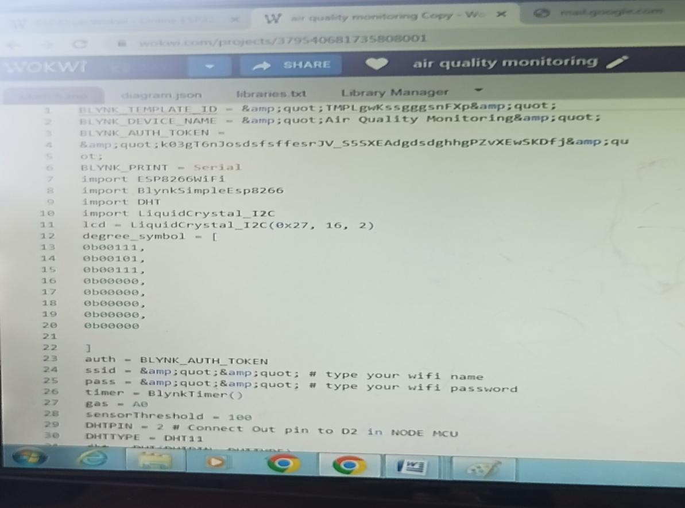

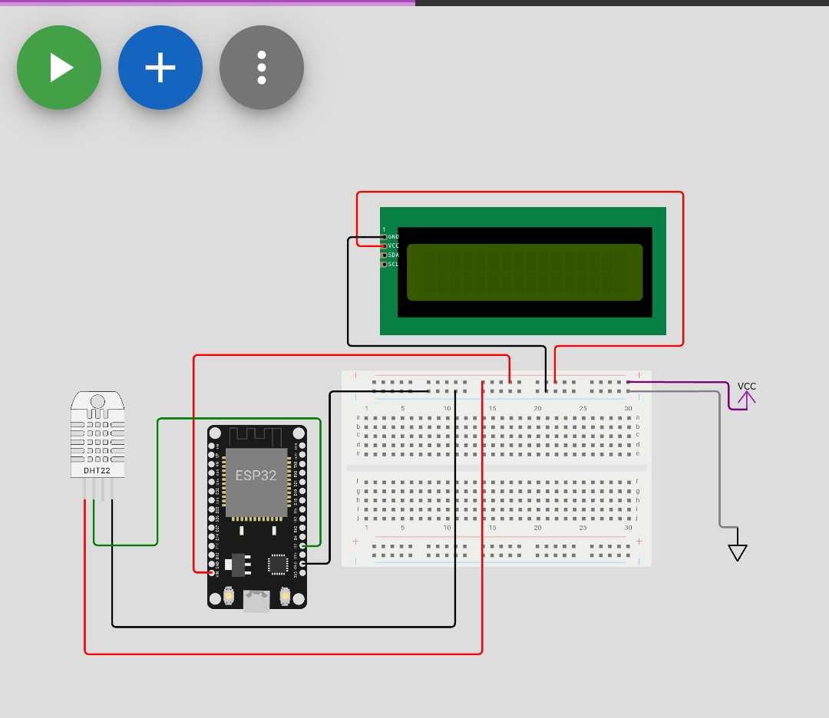

**Conclusion:**

As a conclusion, the Air Quality Monitoring System with IoT has achieved the objective that able to detect air pollution or harmful gases by using MQ135 gas sensor. It is also capable of spreading awareness of how important to know the effects of air pollution towards healthy and environment. The following objective which is to develop the monitoring system of air pollution for environmental sensing application using Internet of Things has also been fulfilled. The entire system includes the hardware components such as the Arduino Uno microcontroller, MQ135 gas sensor, I2C LCD and NodeMCU (ESP8266) as well as the software components comprising of the Arduino IDE, Blynk platform for database system.